EPSON P20000

How-To Guide
December 2025

Read before Using the Printer

Please note that the Post-Image lab is organized with limited on-site technical and administrative support. After the workshop accreditation you are expected to operate the printer independently. Use this How-to Guide to help you do that.

You are expected to troubleshoot any problems or errors that occur during your use of the printer. The printer manual is available at the workstation. If you experience problems while printing you must record them as well as your troubleshooting process in the troubleshooting logbook that can be found on the computer Desktop in the file called Error Log.webloc. If you are unable to solve the problem yourself, please contact us at postimage@concordia.ca and we will look into it as soon as we are able.

Please be respectful and considerate of the equipment and only use it for its intended purpose. We are open for experimentation, but if you are interested in printing on unusual surfaces, please consult the lab coordinators first.

After your printing session please return the workstation to its found state. Unload the paper and return it to the paper storage. Please be respectful of the users who will use the workstation after you.

PRINTER CONTROL PANEL

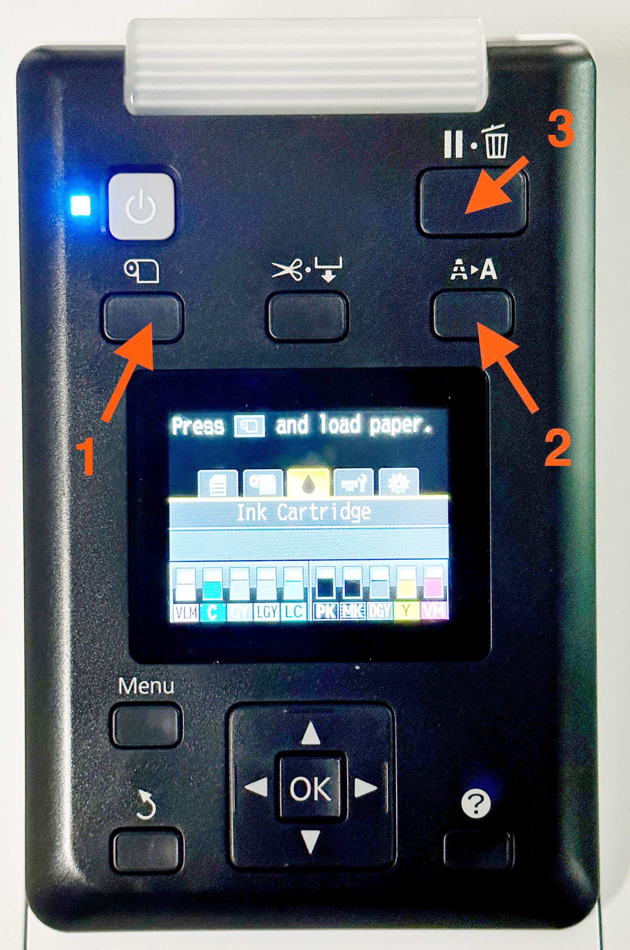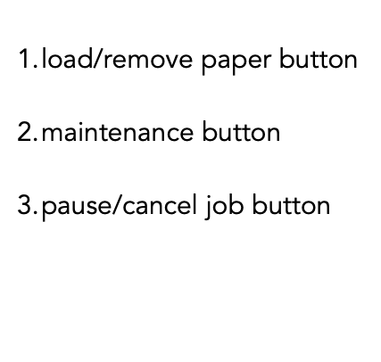

LOADING PAPER

Power on the printer (press Power button on the printer Control Panel), then take the paper roll and place it on the roll guides on top of the printer.

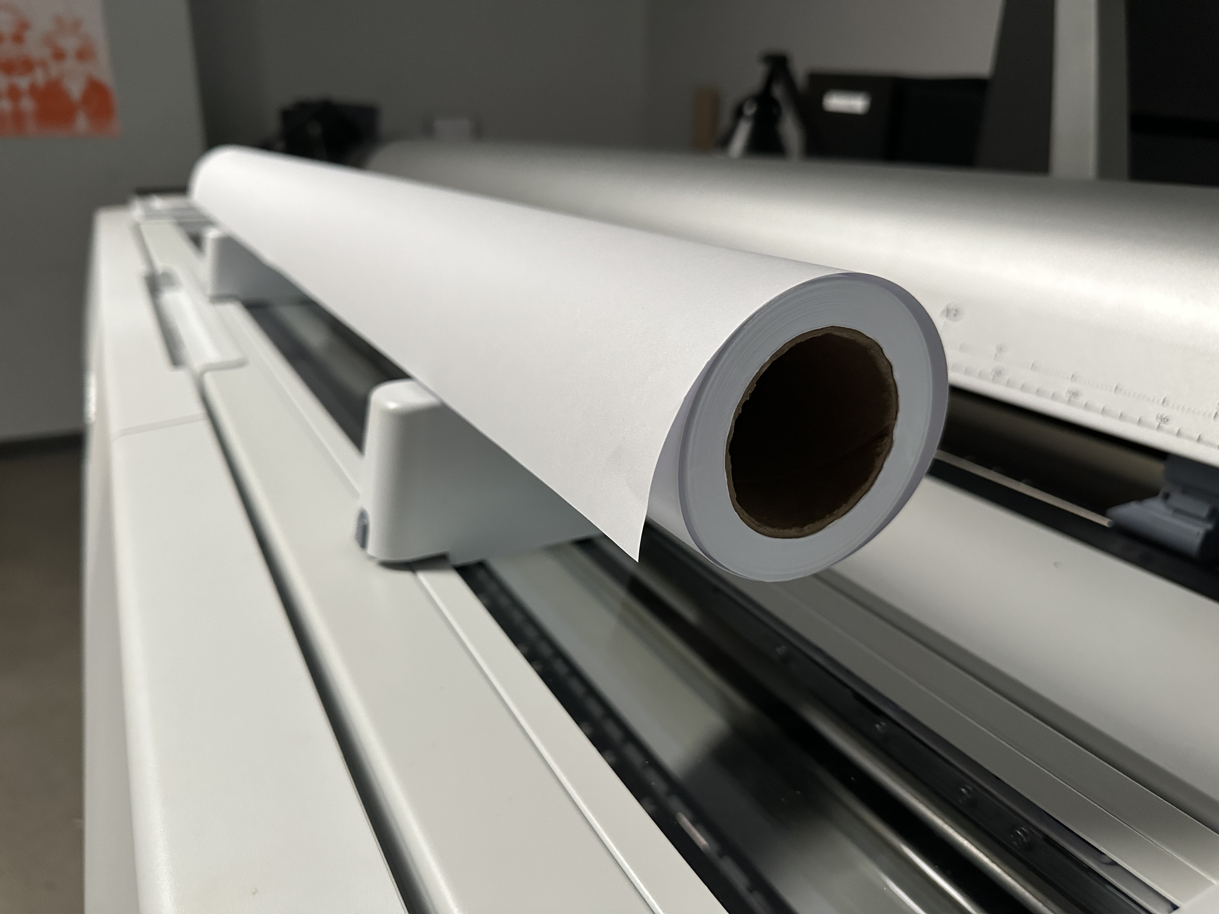

Lift the cover at the back of the printer and take out both roll paper adapters.

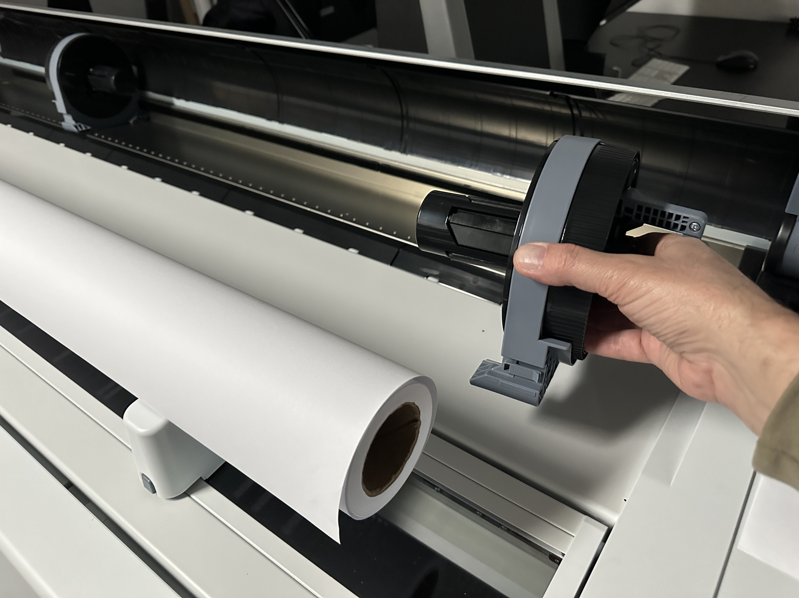

Make adjustments for the desired roll diameter (Bond 44” has 2” core, all the other papers have 3” core) by sliding the size lever to the side that matches your paper core size.

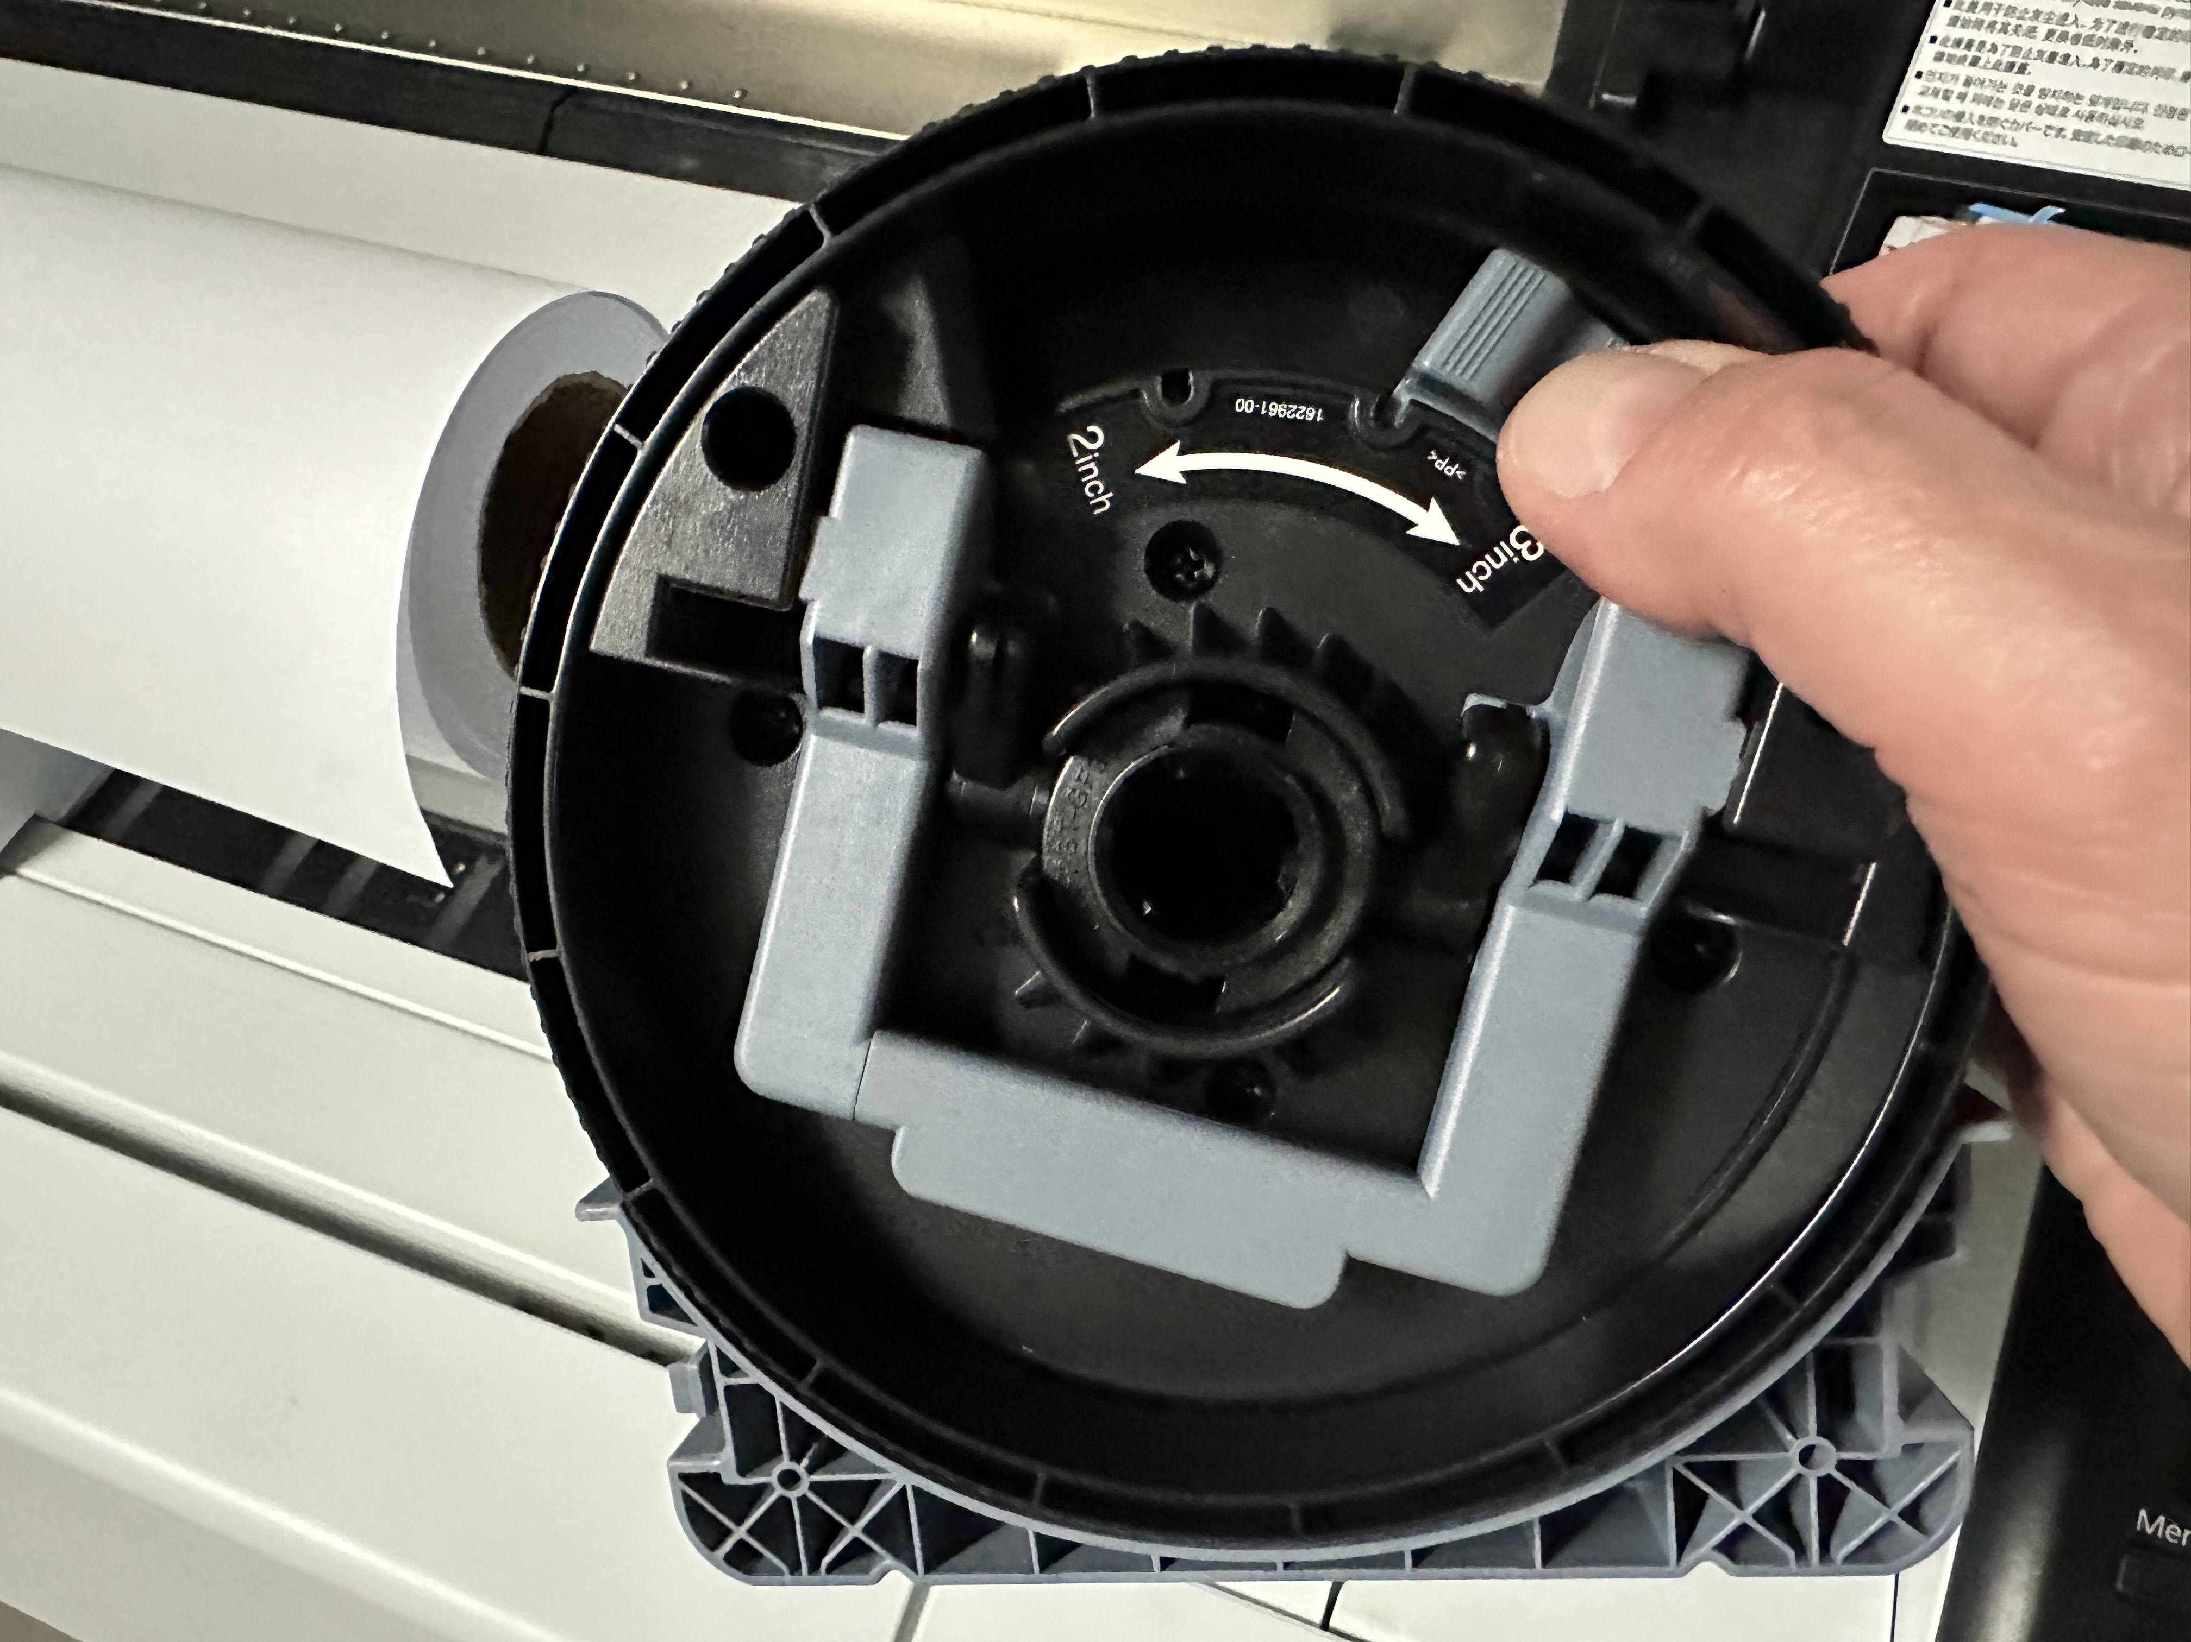

Release (lift) the adapter lock on both roll paper adapters.

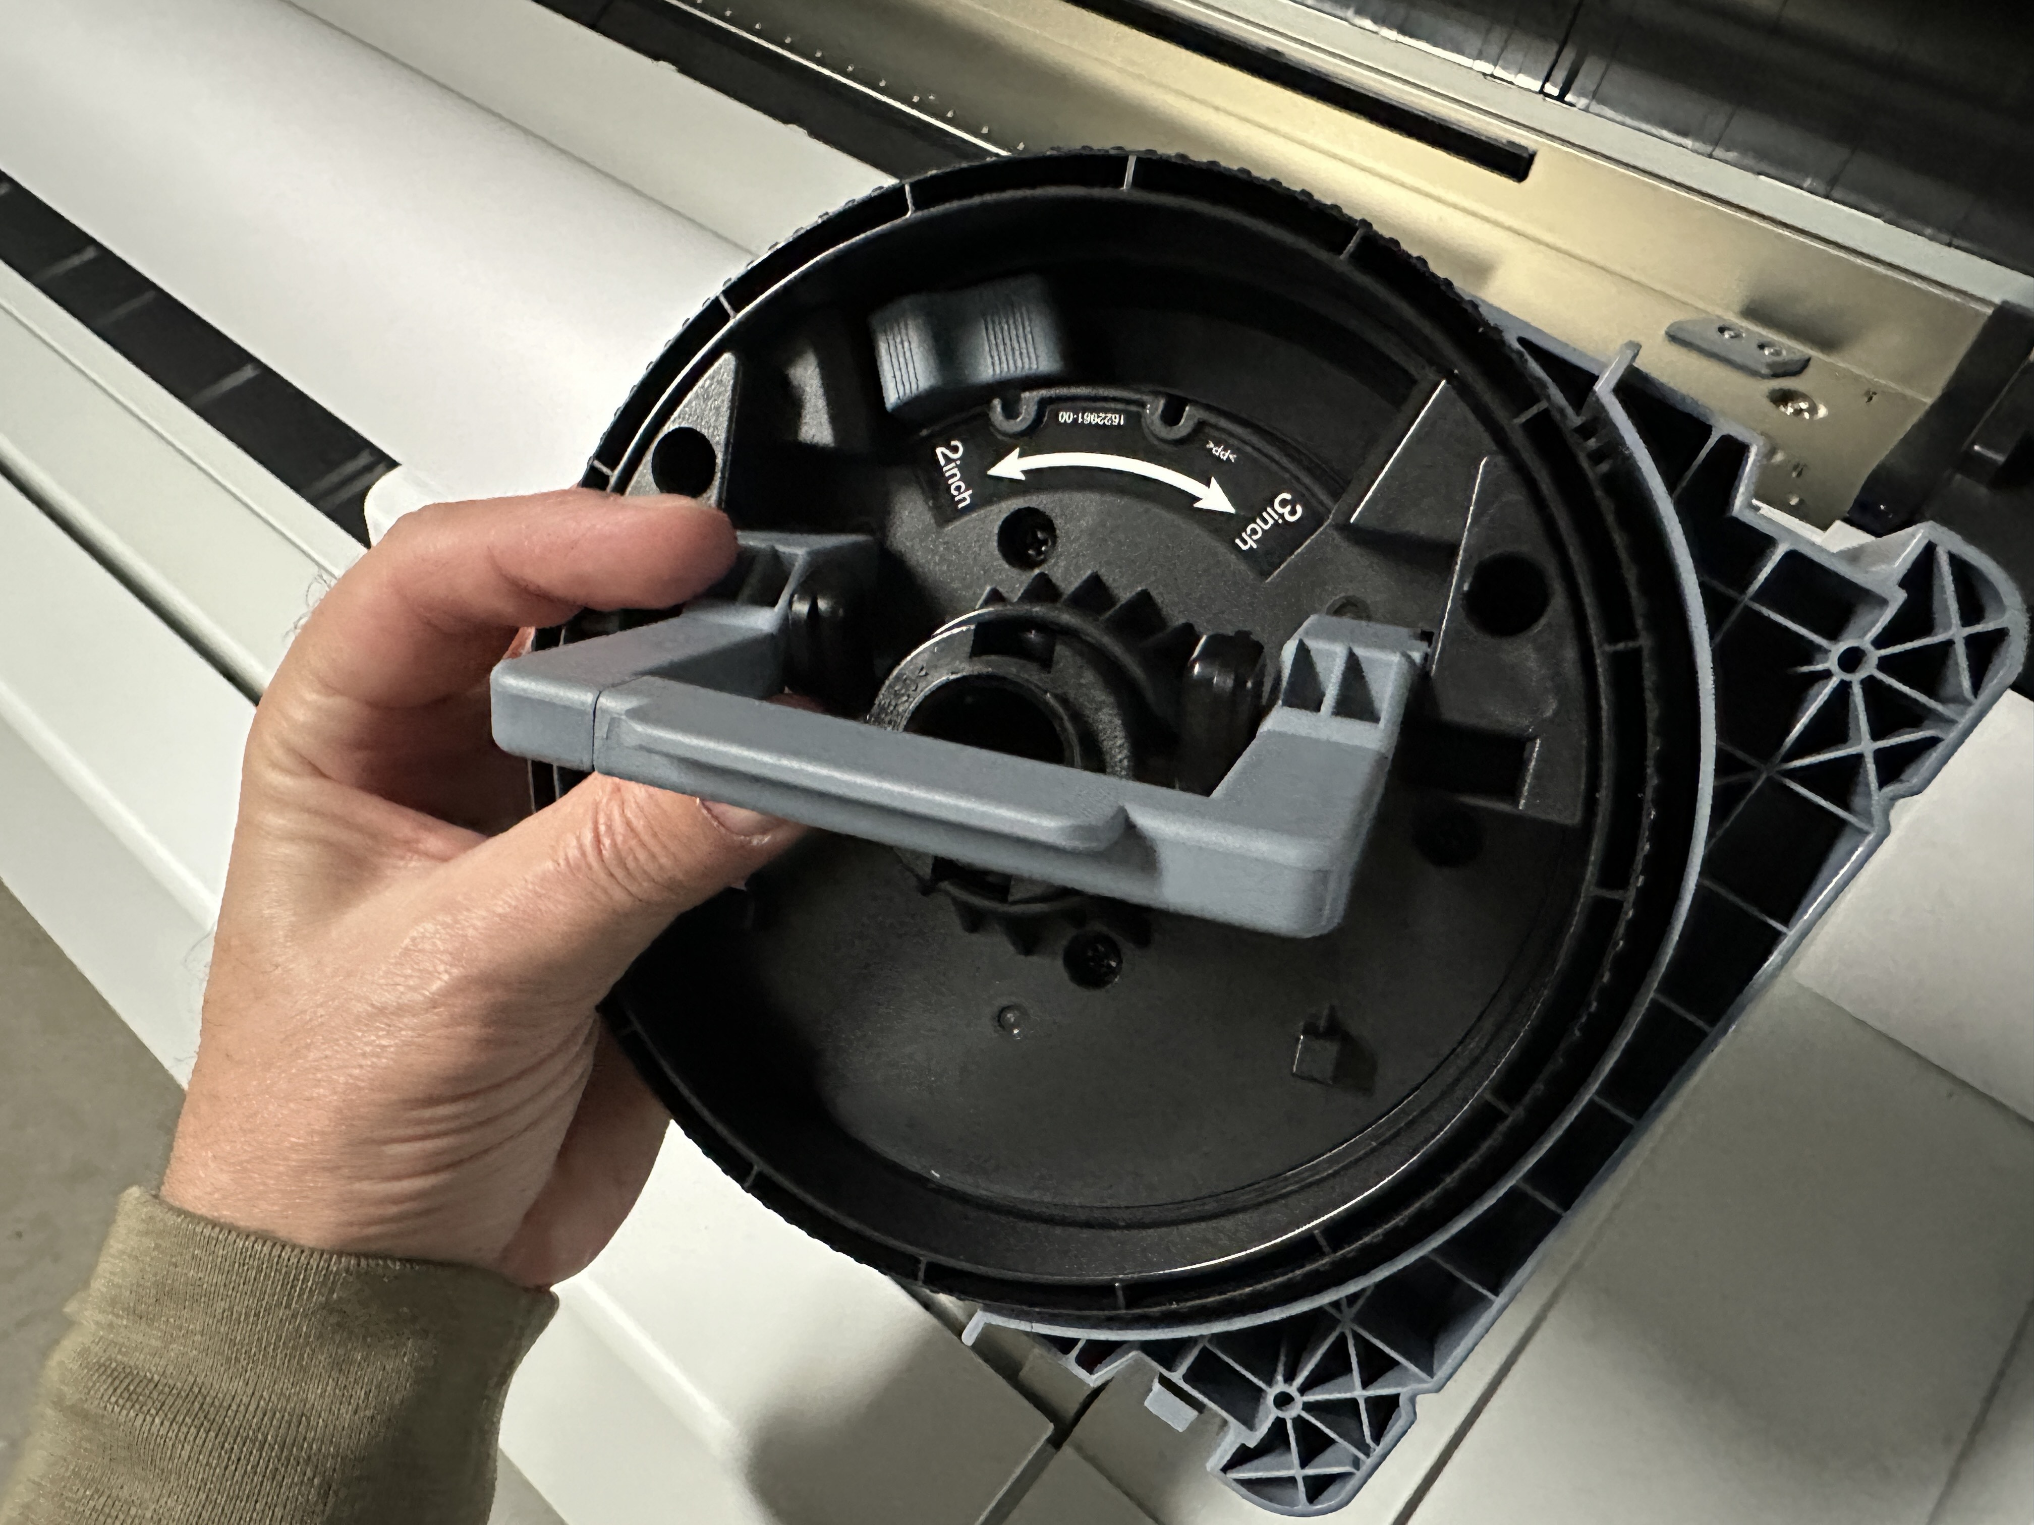

Push adapters into the paper core at both ends of the roll and push down the adapter lock levers flat against the adapters.

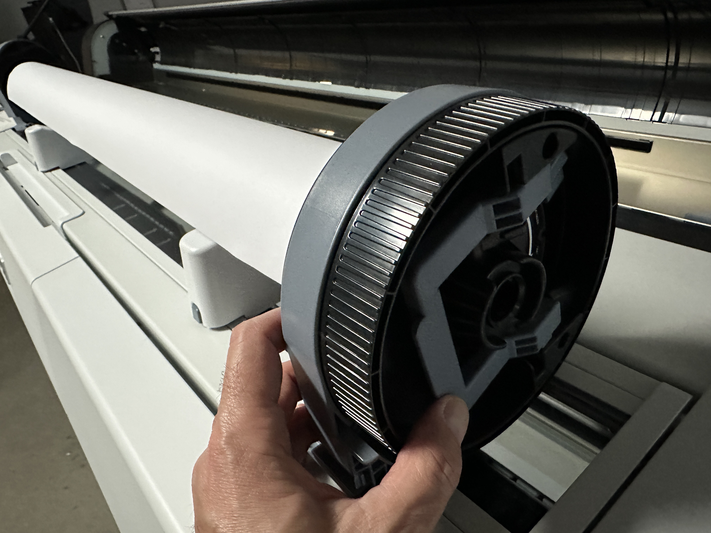

Lift the roll and slide it back and to the right until it meets roll paper guide.

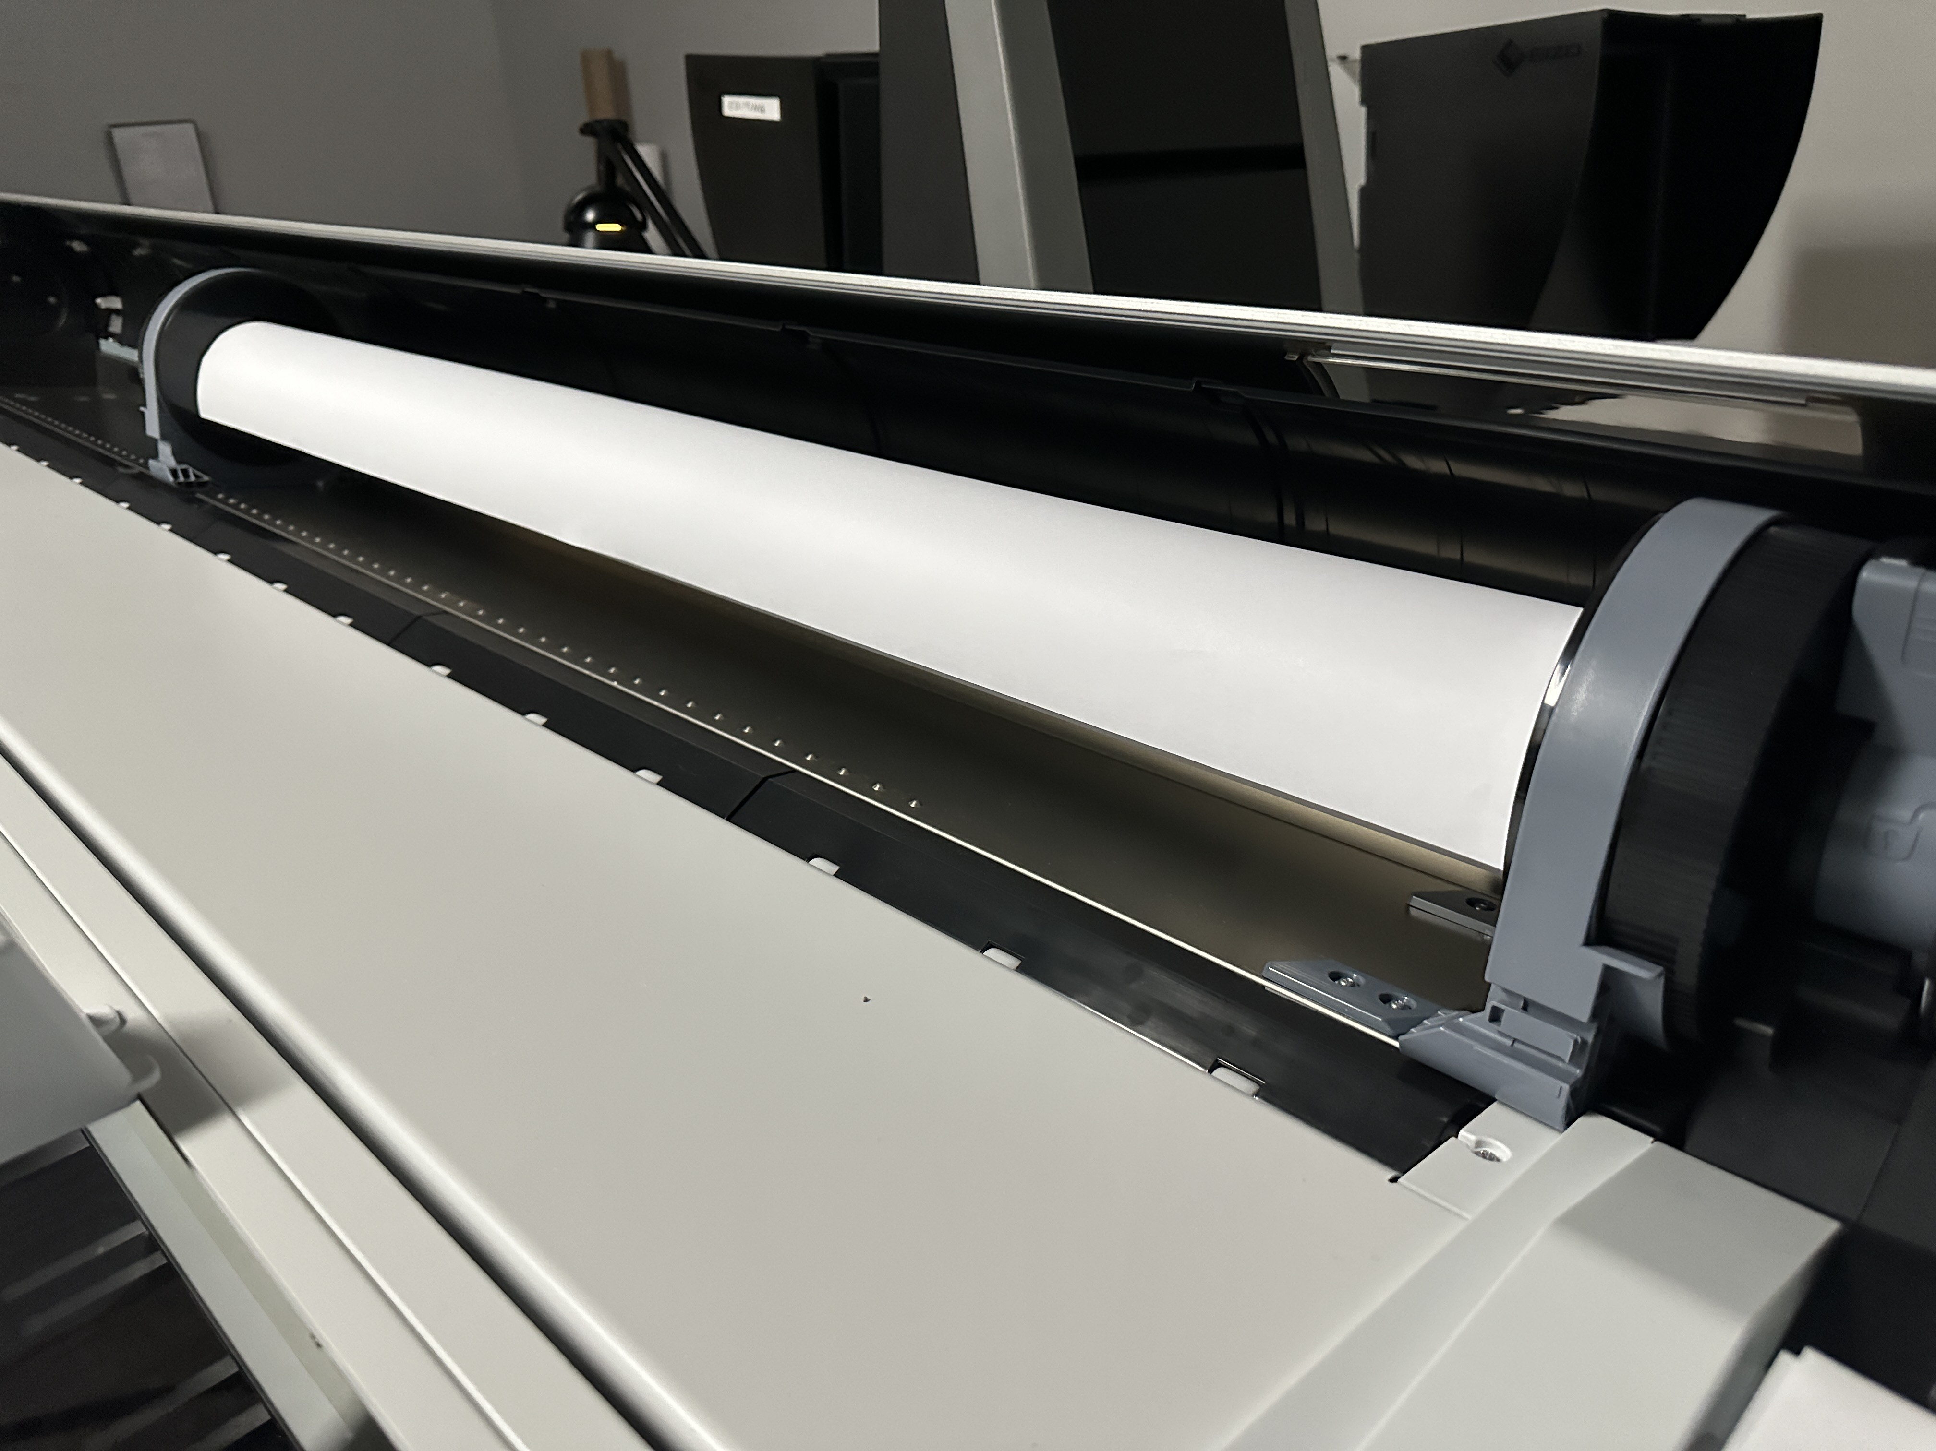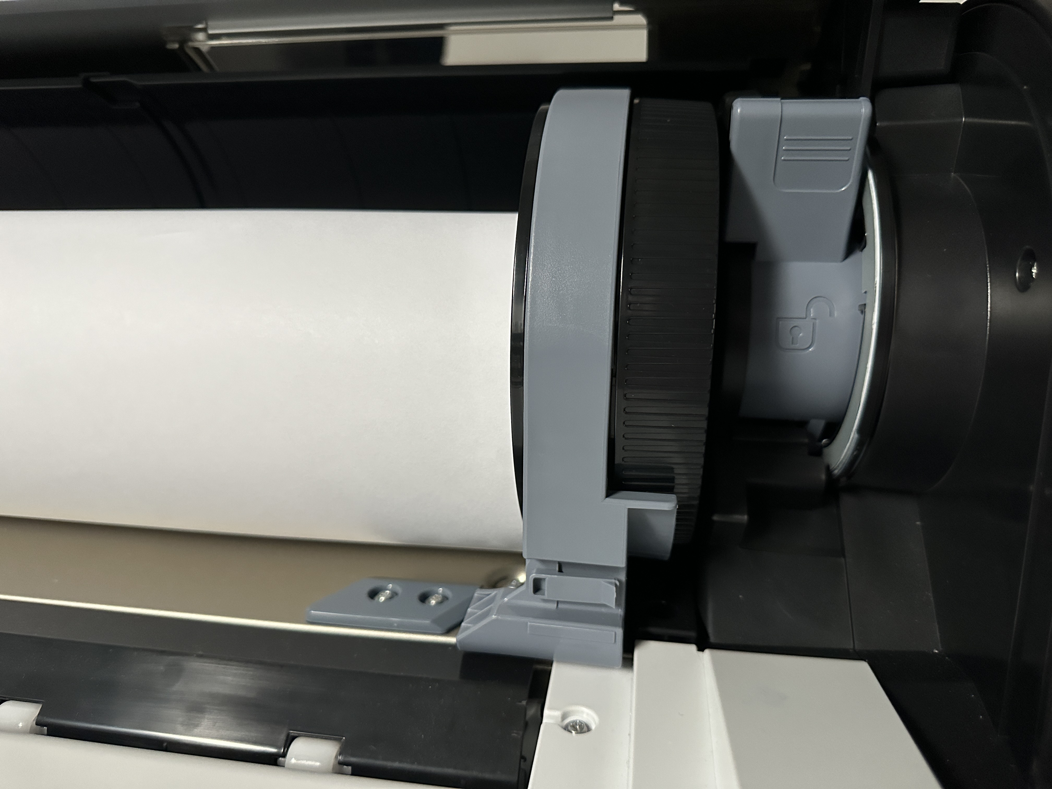

On the printer Control Panel press load/remove paper button.

Make sure that on the Control Panel LCD display Roll Paper is selected and press the OK button.

Insert the leading edge of the roll paper into the feed slot until the printer beeps.

Pull down the roll lock lever to lock the roll in place.

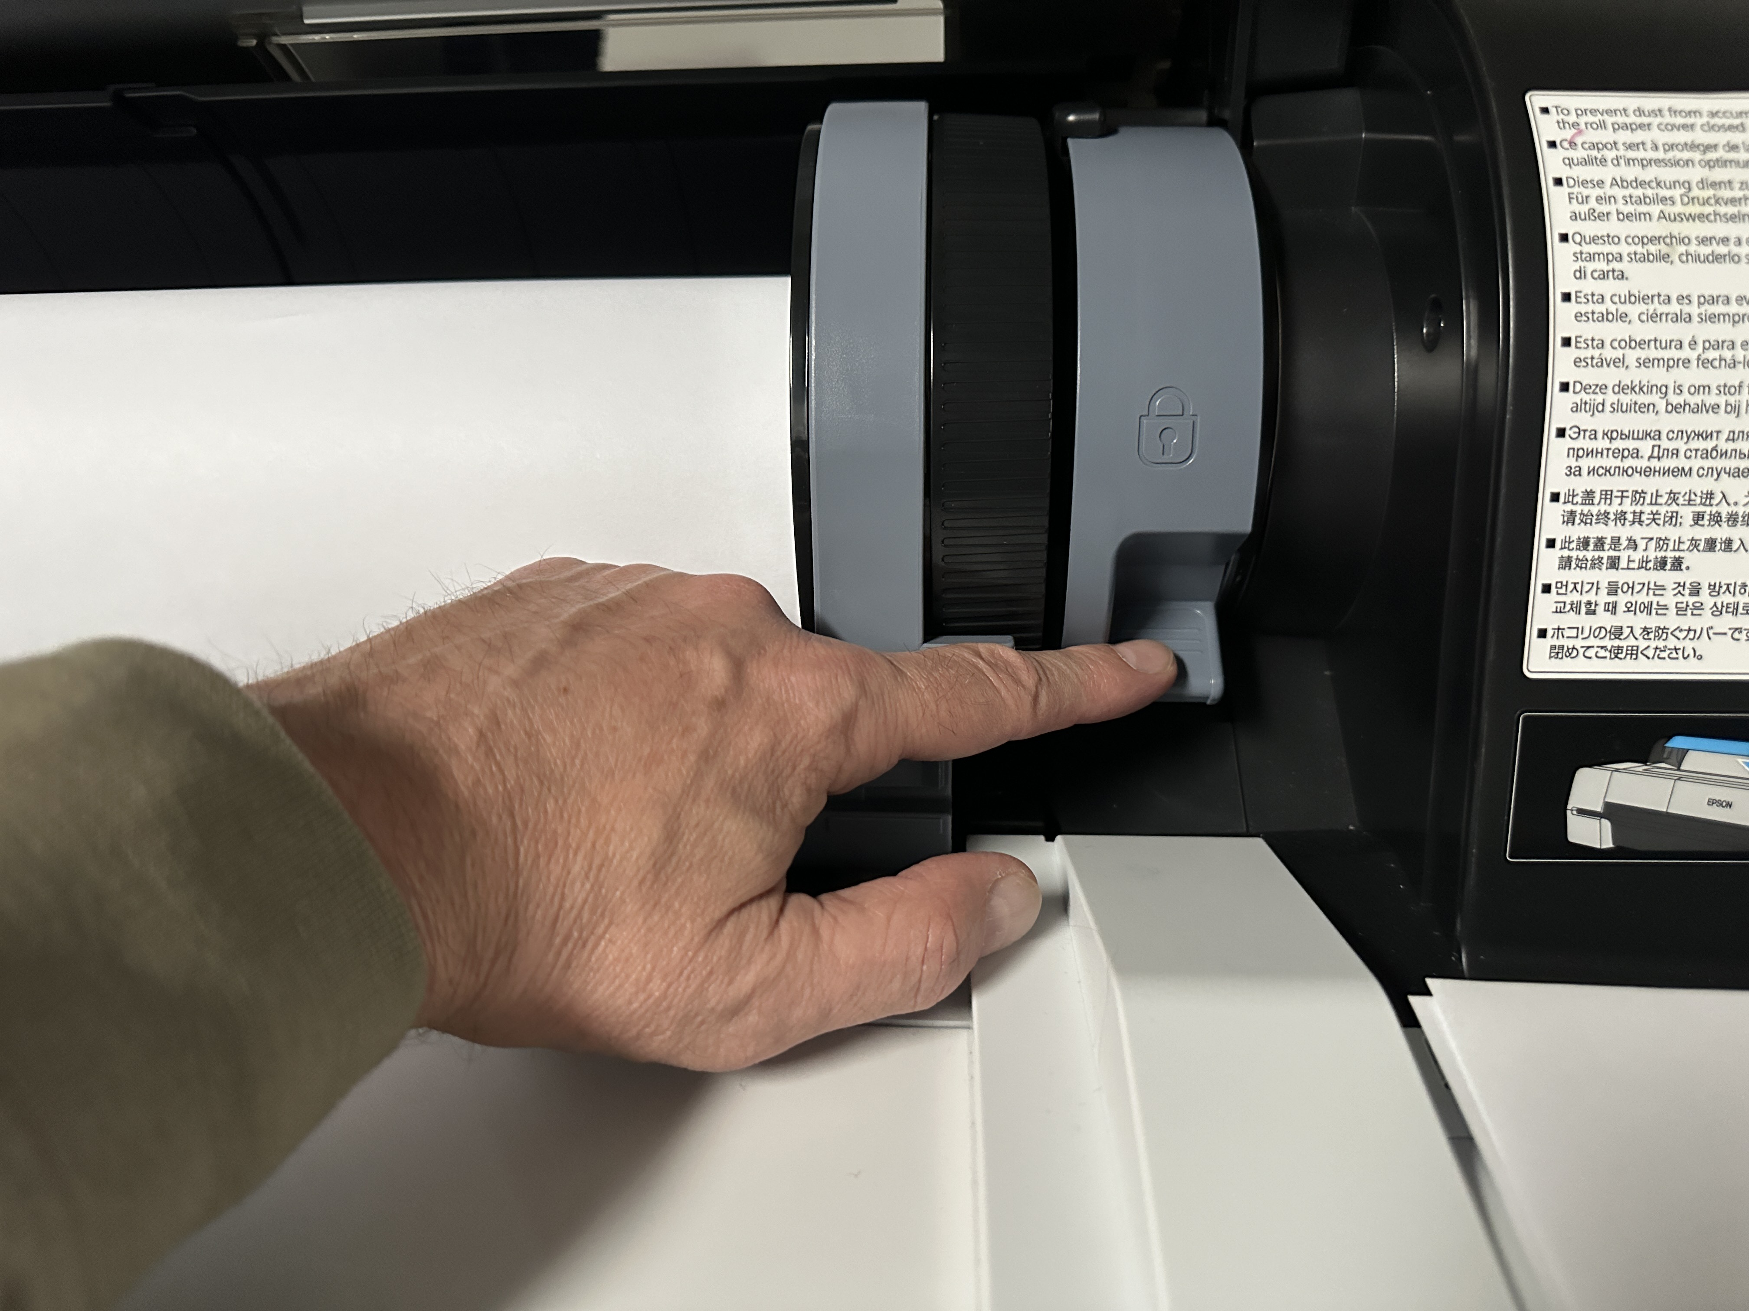

Close the roll paper cover. Always keep the cover closed unless loading or unloading media.

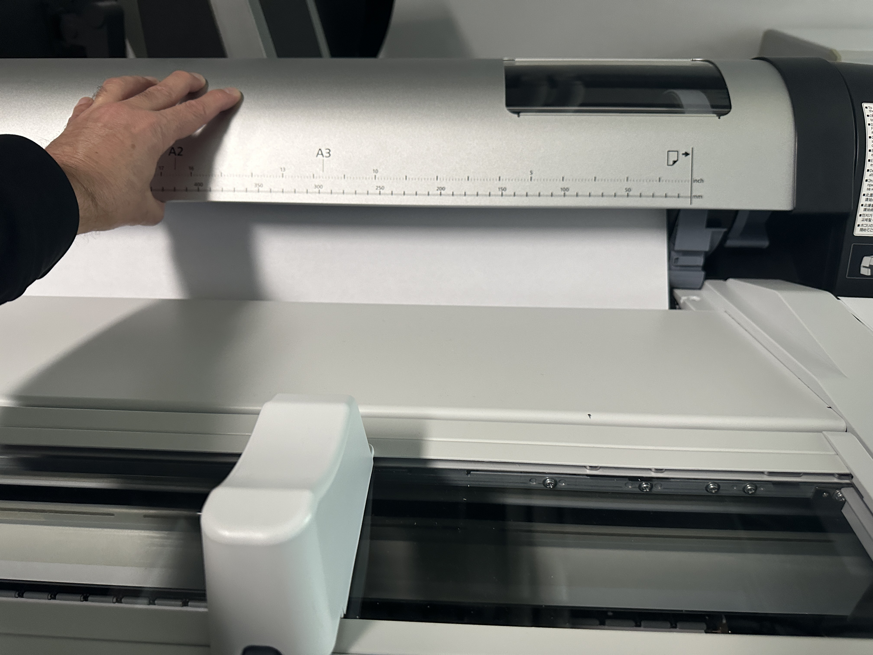

Check the Control Panel LCD screen.

If the paper settings on the screen are the same as the paper type you loaded, select Keep Settings Above.
If the paper settings are different than the paper type you loaded, select Change Settings and then select the proper paper type.

For the papers we offer in the lab, select the following paper type offered on the screen:

Bond = Plain Paper
Enhanced Matte = Enhanced Matte Paper
Glossy = Premium Glossy Photo Paper (250)
Satin = Premium Luster Photo Paper (260)
Photorag = UltraSmooth Fine Art Paper
Backlit = Backlit (Thin)

Press the OK button.

PRINTING STEP-BY-STEP

Perform Nozzle Check (there are 2 ways to do it).

Either:

On the computer, open Epson Print Utility 4 (in the Dock). Select Nozzle check and print the check pattern. Upon inspection of the printed pattern, if necessary, clean the nozzles by selecting Head Cleaning and pressing Start. After the Cleaning perform another Nozzle Check and inspect the pattern. Upon completion of the nozzle check make sure to click Finish in the Epson Print Utility 4 pop-up window.

Or:

On the Control Panel on the printer press the Maintenance Button.
Select Print Nozzle Check. Upon inspection of the printed pattern, if necessary, clean the nozzles: Press the Maintenance Button. Select Head Cleaning. Select Nozzles to be cleaned (all nozzles selected by default) and press OK. After the Cleaning perform another Nozzle Check and inspect the pattern.

Note that a few intermittent nozzles missing (like in the example below) should not affect the quality of your print. Only if segments (blocks) of nozzles are missing the cleaning is required.
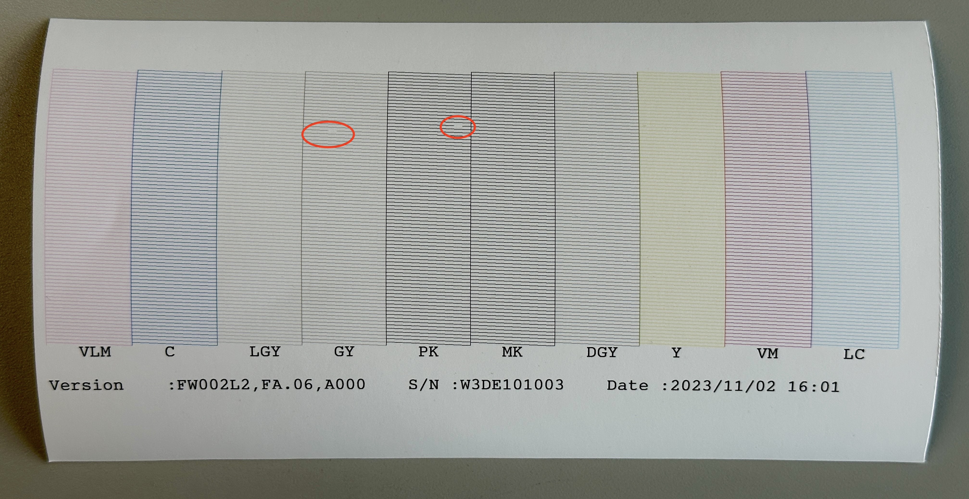

When you have your document prepared in Photoshop, in the menu bar select File ➝ Print.

Make sure that “EPSON SC-P20000 Series” is selected as the printer. Don’t worry about page size, position, or scaling yet. This will be set up soon. First, set the color handling:

Color print: Select Photoshop Manages Colors, and then choose the correct printer profile for the type of paper you’re using. Each profile created in this lab for the papers we offer will be labeled with Post-Image. For example, if you were printing on the Enhanced Matte paper you would use the Post Image Enhanced Matte.icc.

Select: Epson P20000 Network (Bonjour)
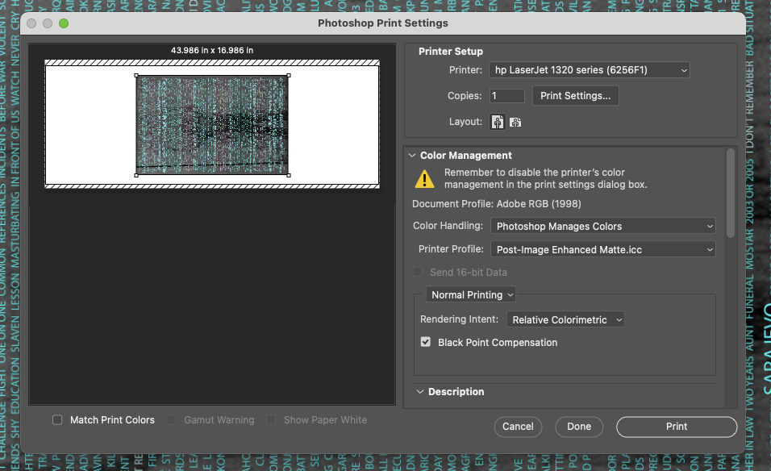
Click on “Print Settings…” which will bring up the Print window:

Select: Epson P20000 Network (Bonjour)

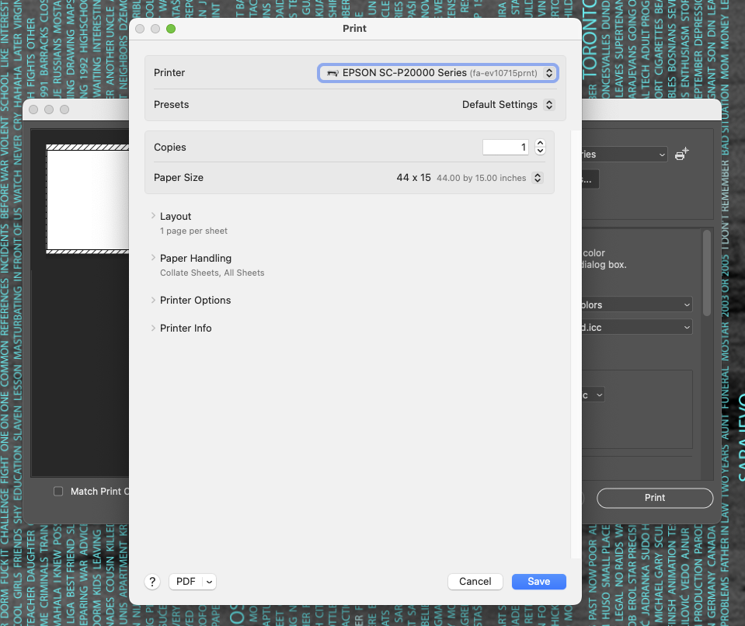

Note that the Presets function is unreliable at the moment (Mac OS Issue). Each time you open the Print Settings dialogue you need to make selections in the following fields:

For paper size, click on the options under “Paper Size”. Presets have been made for all of our roll paper widths, in heights from 11” to 70”. To make your own custom size, select “Manage Custom Sizes” at the end of the list of paper sizes. Please remember to name your custom size! Note that the minimum paper size to print is 11”!

Expand Printer Options pull down menu. Then select Printer Settings (click on the name or the “i” button)

Select: Epson P20000 Network (Bonjour)

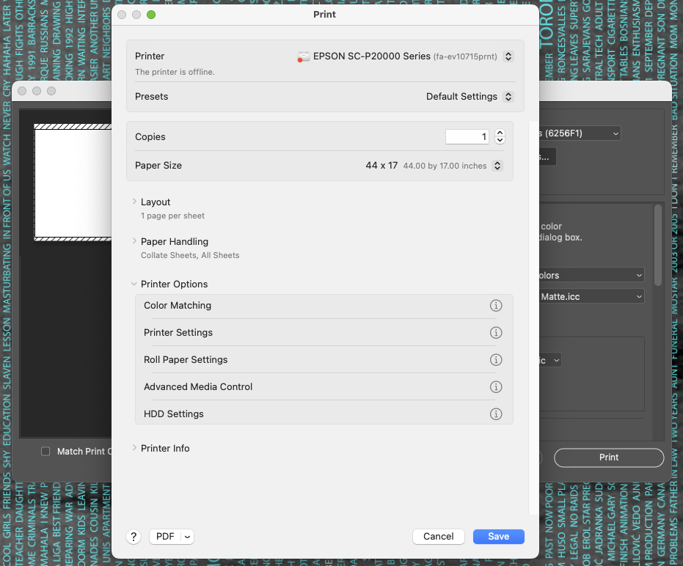

Under Page Setup select Roll Paper:

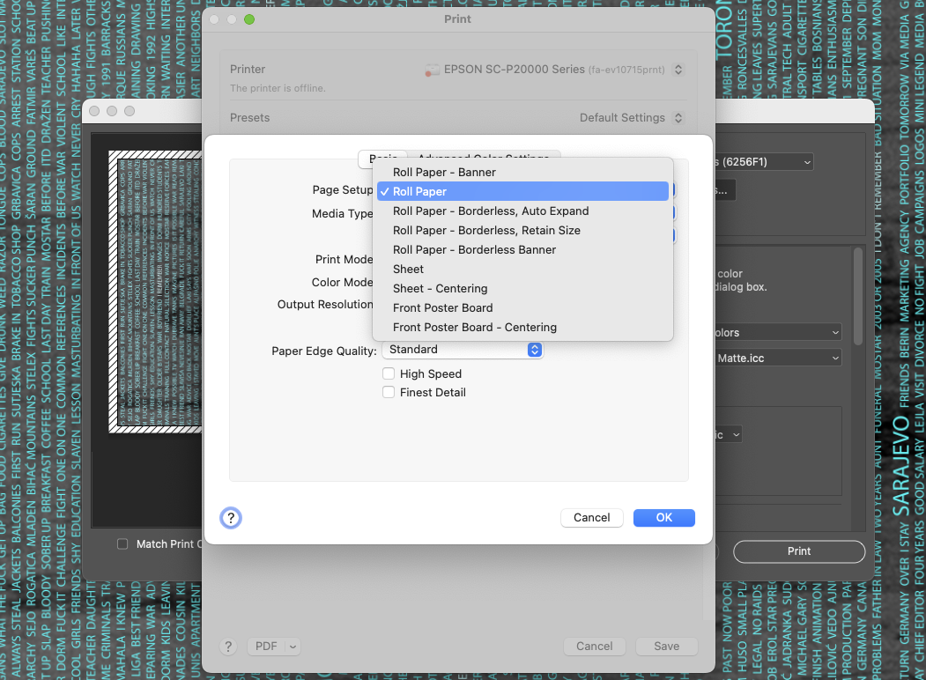
Select Media Type to reflect the selection made already on the Printer display:

Bond = Plain Paper
Enhanced Matte = Enhanced Matte Paper
Glossy = Premium Glossy Photo Paper (250)
Satin = Premium Luster Photo Paper (260)
Photorag = UltraSmooth Fine Art Paper
Backlit = Enhanced Matt

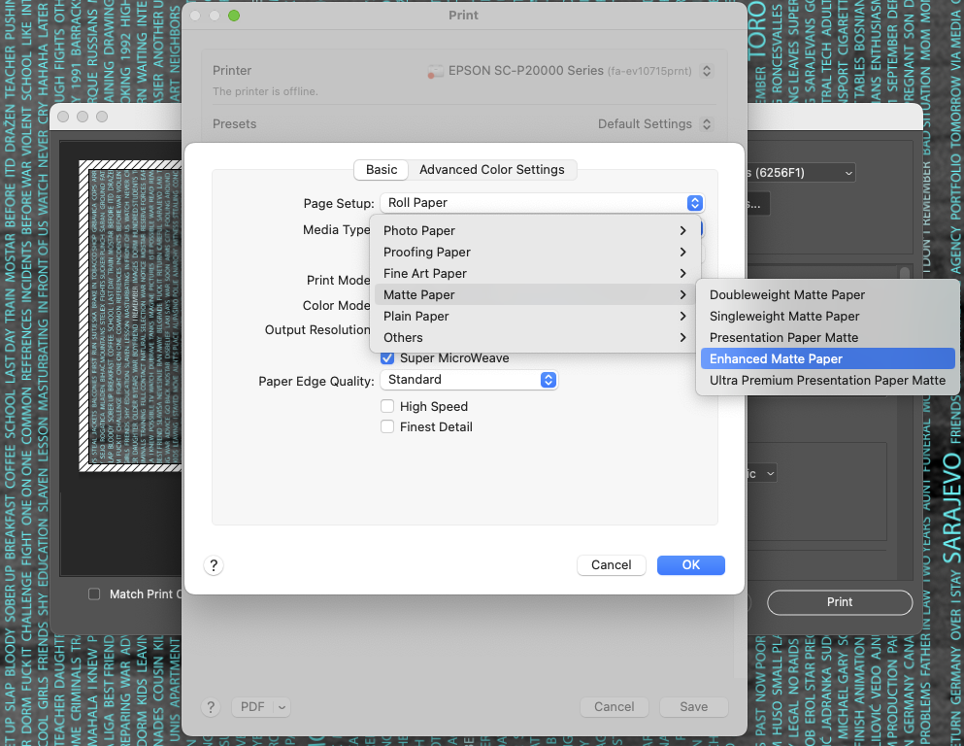

Select desired Output Resolution – 600dpi is fine for most cases:

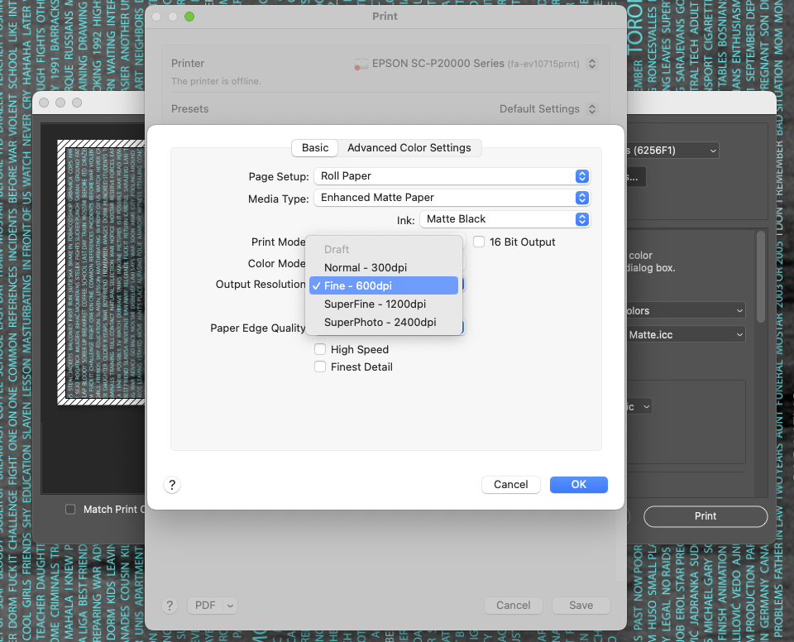

If selected, make sure to deselect High Speed box.

Click on Advanced Media Control and select the appropriate Paper thickness as per table below:

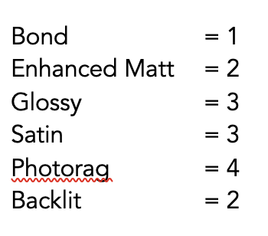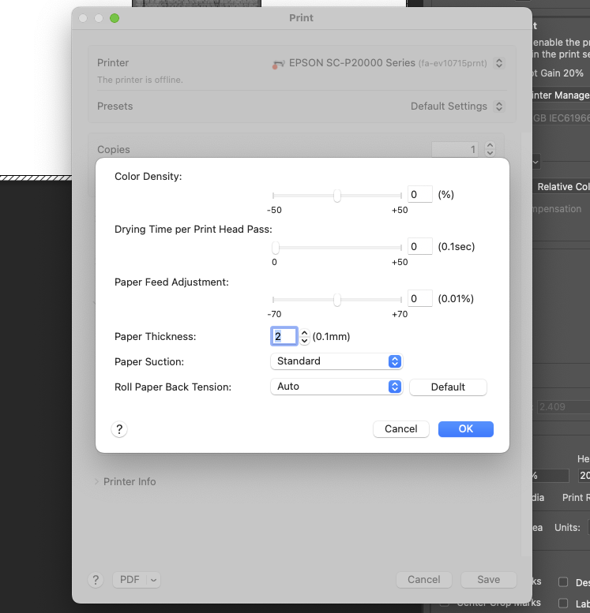

Press the OK button to print.

For Black and White print: Select Printer Manages Colors. Option to select Printer Profile is not available and it’s not necessary.

Select: Epson P20000 Network (Bonjour)

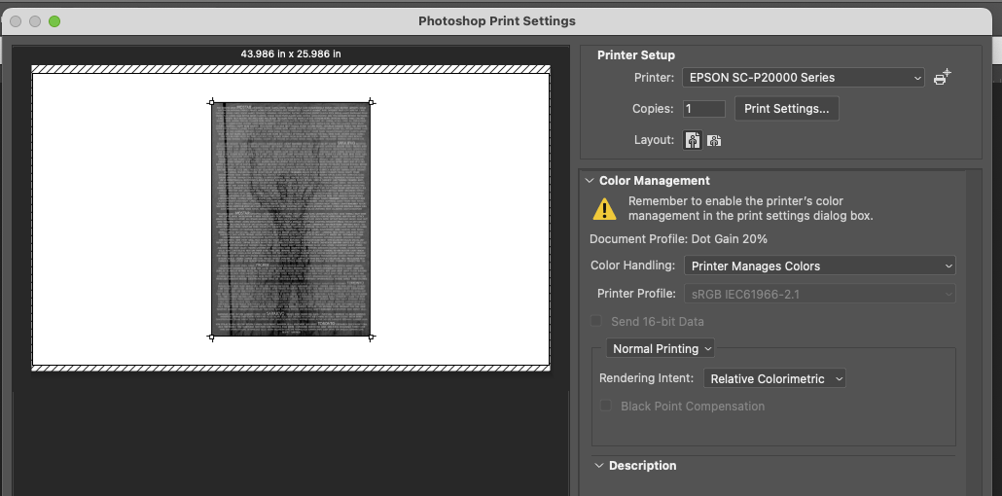

Click on Print Settings, expend Printer Options pull down menu, then select Color Matching and choose Epson Color Controls:

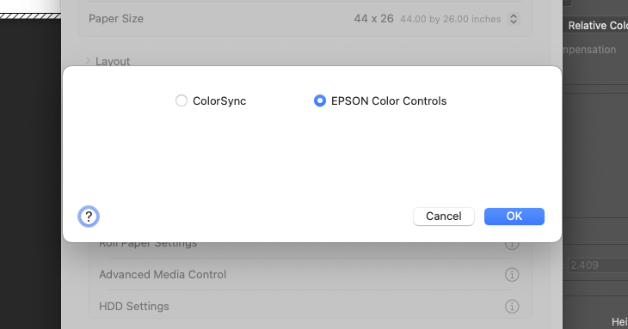

Make the following selections in the Basic settings (select appropriate Media Type for the paper you are using, select Advanced B&W Photo as a Print Mode):

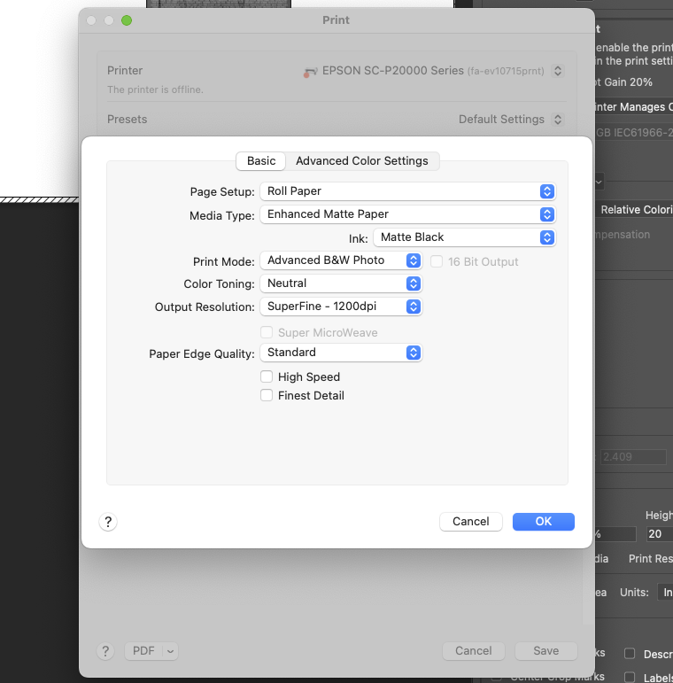

The rest of the settings is the same as for the Color prints, including setting the paper thickness in the Advanced Media Control (don’t forget that!).

KNOWN ISSUES
Error message after printing: “The following nozzle(s) are clogged.”

If several colors are listed: Click Finish ( II ) then do a nozzle check before cleaning.
Often, even though you get this message no nozzle is clogged. Perform cleaning only after you see a confirmation of the problem in the nozzle check print.

WHEN YOU ARE DONE PRINTING

On the printer Control Panel press load/remove paper button.

On the Control Panel LCD display select Remove Paper and press the OK button.

The paper will automatically rewind back onto the core.
Pull up the roll lock lever to unlock the roll. Remove the roll paper and put it back in the same slot on the paper stand that you took it from (there are labels on the stand).

HOW TO LOG YOUR USAGE

Log your paper usage in linear inch in the log book. The linear inch is the length you choose in page setup for printing (e.g. 44 x 68 = 68 linear inch). If you make several prints, please take note of each length, and calculate the total.

With the online print log you can see a log of all the print jobs you sent, including the
length for each print job. This can be useful when you have many paper sizes to log. When calculating the total, please ignore the numbers behind the decimal (e.g.
56.845 inch = 56 inch).

To access the log, open Safari: https://port.epson.com/app/cost
A new Safari browser window will bring you straight there, as this URL is set as home page.

In case you are asked to login, here are the credentials:
ID: postimage@concordia.ca
pw: +M0ntreal
(the credentials are also saved in the browser)

The print log will look like this:

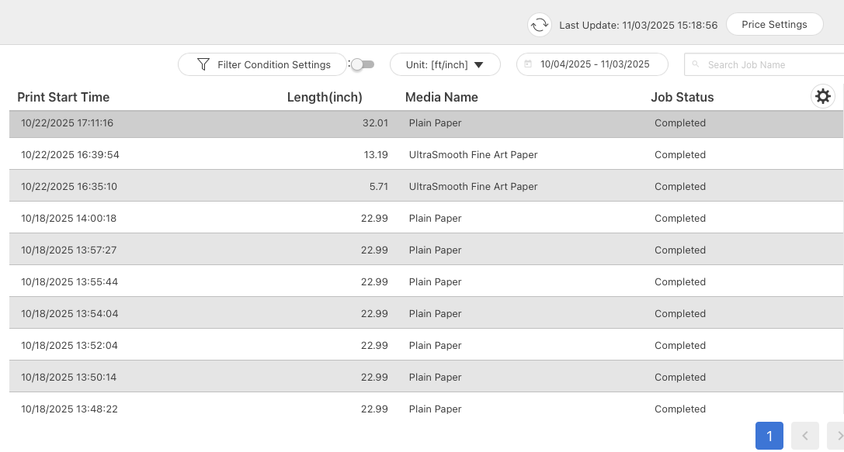

MATERIAL USAGE GUIDELINES IN CASE OF PROBLEMS

I.) You will receive an invoice for the material you used. You will have to pay for all materials, no matter if it was for tests (including Nozzle check), due to errors – or the final print. However, if there was a problem with the printer and you think you will be unfairly charged, please do the following:
– keep all the prints with the errors, including nozzle checks, etc
– immediately inform the lab staff by sending an e-mail to postimage@concordia.ca
– together we will look at the case, and depending on the circumstances, you might get a reduction in your invoice.
– If you get a reduction, we will ask you to hand over the prints you did not pay for, as print samples will help us fixing technical problems

II.) You are expected to operate the equipment yourself. If there is a problem, you also must be prepared to do some troubleshooting. If the troubleshooting involves paper and ink use which exceeds what you think is part of a regular printing job (or what you think you are willing to pay), please stop and immediately inform the lab staff by sending an e-mail to postimage@concordia.ca
Make sure that you keep all the prints/ nozzle checks. It is much easier to figure out the problem if we have something in hand.

PROBLEMS?
If you experienced problems while printing remember to record them in the troubleshooting logbook that can be found on the printer station desk.

If you are unable to solve the problem yourself, please email postimage@concordia.ca.
If possible, leave a sample of the print with the problem.

